1. This project is about building a security system for my house. The system has 3 input, active state, door sensor, Secret deactivate button and one output, the loud alarm. If the system is in active state and the deactivate button have not been activated and the door sensor is activated, then it will activate the alarm.
2. 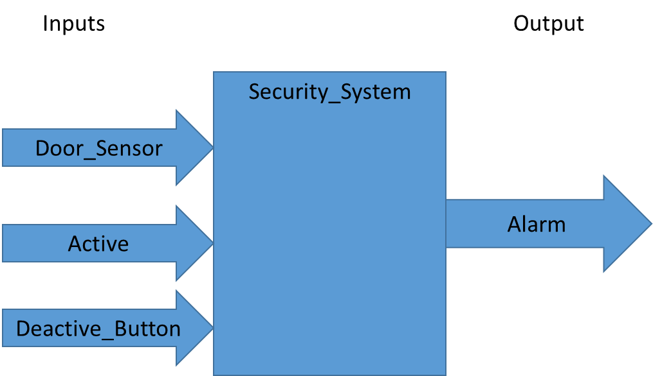

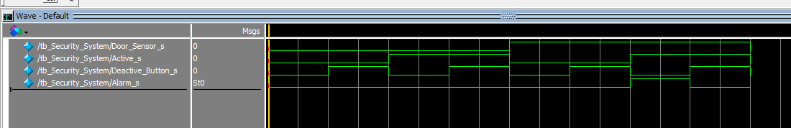

1. The Code

-Main Module:

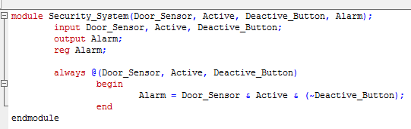-

-TestBench Module:

